Green Beans
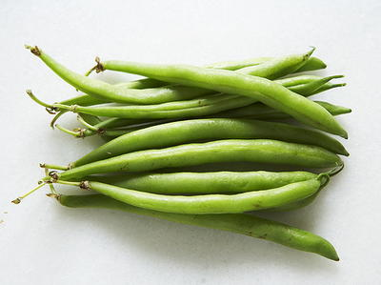
Also known as the “string bean”, green beans, are one of the most popular vegetables to grow in the world. Like peas, they are harvested when they are young and eaten with the shell. Green beans are grown in two ways: on bushes, which produce a lot of beans all at once, or on plants with long vines which produce beans throughout the growing season. There are at least 130 different varieties of green beans; most are green but some are purple, yellow, or even spotted.
Selection: The first detail to evaluate is color…the beans should be a bright green without any yellow or brown spots/hues. The skin on the beans should be smooth and tight and should snap when bent. Tight skin will ensure your green beans are fresh and delicious. Avoid green beans that are too large/thick, these beans can be quite tough and stringy. Finally, check the beans for moisture, just touch the beans and if they feel moist, they will be perfectly sweet!
Storage: The best way to keep green beans fresh is to keep them in the crisper drawer of your refrigerator in a plastic bag. Do not wash them or snip off the ends until you are ready to eat them.
Nutrients/nutrition: On average, a 1 cup serving of green beans have about 30 calories, 7 grams of carbohydrate and nearly 2 grams of protein. They are an excellent source of vitamin C, providing about 27% of your daily value, as well as 13% of the daily value of fiber. They help reduce the risk of heart disease, colon cancer, and diabetes while boosting your immune and digestive system. They are also beneficial to your eyes, bones, and can help reduce the risk of birth defects for pregnant women.
Preparation: After washing, green beans can be eaten raw or cooked. They can be added to salads (vegetable, potato or pasta) for a nice pop of color and crunch. They can also be sautéed in butter or olive oil with garlic, salt and pepper for a delicious side dish. Green beans are also commonly dried and used in soups or stews, or simply steamed!

Eat well to be well!

