Nourse Farm Food Fact Sheet
Beets
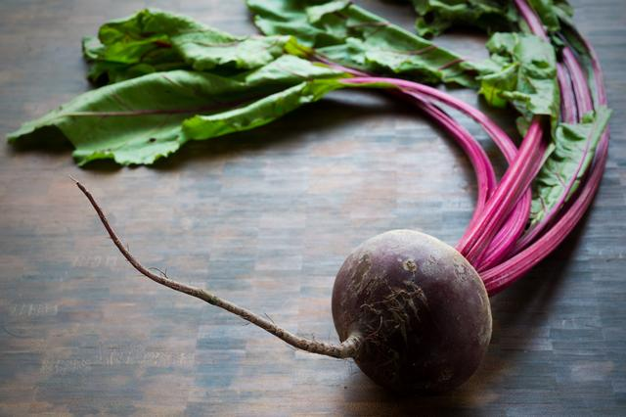

Beets or beetroots are the taproot (or most dominant root part) of the beet plant. Table beet, garden, red or golden are other names that are used to identify this veggie. Known for its edible root and greens, beets can also be used as a natural food coloring and sweetening product (the sugar beet). They come in a variety of colors: red, white, golden or yellow, and Chioggia (striped) and are most abundant from mid-summer through early fall.

Selection: To find the best beet, look for signs of appropriate freshness, e.g., deep color, unbruised skin and appropriate firmness. Avoid any beets with spots, bruises or wet areas, as these signs may indicate spoilage. Smaller beets may be tender enough to skip the peeling process after they are cooked. Note that the beet greens’ presence or quality does not affect the beet root. However, if you choose to use the green, please select those that are fresh (hydrated) and have a rich green color.

Storage: Trim the majority of the beet greens and their stems from the roots, so they do not pull away moisture away from the root. Leave about 2 inches of the stem attached to prevent the roots from "bleeding." Do not wash beets before storing. Place in a plastic bag and wrap the bag tightly around the beets, removing as much of the air from the bag as possible. Store in the refrigerator where they will keep for up to 3 weeks. Place the unwashed greens in a separate plastic bag squeezing out as much of the air as possible. Place in refrigerator where they will keep fresh for about four days. Raw beets do not freeze well since they tend to become soft upon thawing. Freezing cooked beets is fine; they'll retain their flavor and texture.

Nutrients/nutrition: Beets are low calorie, low fat, and low sodium and provide a body ~34% % of the daily value of folate, 28% of the daily value of manganese, and 15% of the daily value of potassium, as well as 7% of the daily value of iron. Additionally, evidence shows us that beets provide antioxidants (belatin) and anti-inflammatory phytonutrients (betanin, isobetanin, and vulgaxanthin) and have been shown to assist the body in natural detoxification actions.
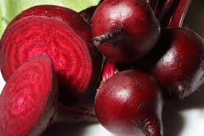
Preparation: Chop, dice or slice beets for easy meal accompaniments, but always remember to rinse them (gently, remember avoid bruising/tearing to contain their pigment), under cold running water. If some of the red beet juice does stain your skin, rub it promptly with lemon juice to remove. The cooking method recommended to retain the most nutrients is steaming...~15 minutes works well. Fill the bottom of the steamer with ~2 inches of water and bring to rapid boil. Add the beets, cover, and steam. Insert a fork into the beet to check for doneness—it should slide in easily (no effort) if done. Remove or peel the beets’ skin by rubbing the skin with a paper towel so as to avoid staining your hands. Roasting beets is also popular—rinse, peel, toss with olive oil and roast at 400 F for ~30 to 45 minutes (smaller beets less time, larger ones more). Do note that beets’ color can be altered during the cooking process. Acid ingredients like lemon juice brighten their color, while more basic of alkaline ones will deepen it.
Eat well to be well!
All information is adapted from the United States Department of Agriculture (USDA)

