Nourse Farm Food Fact Sheet
Swiss chard
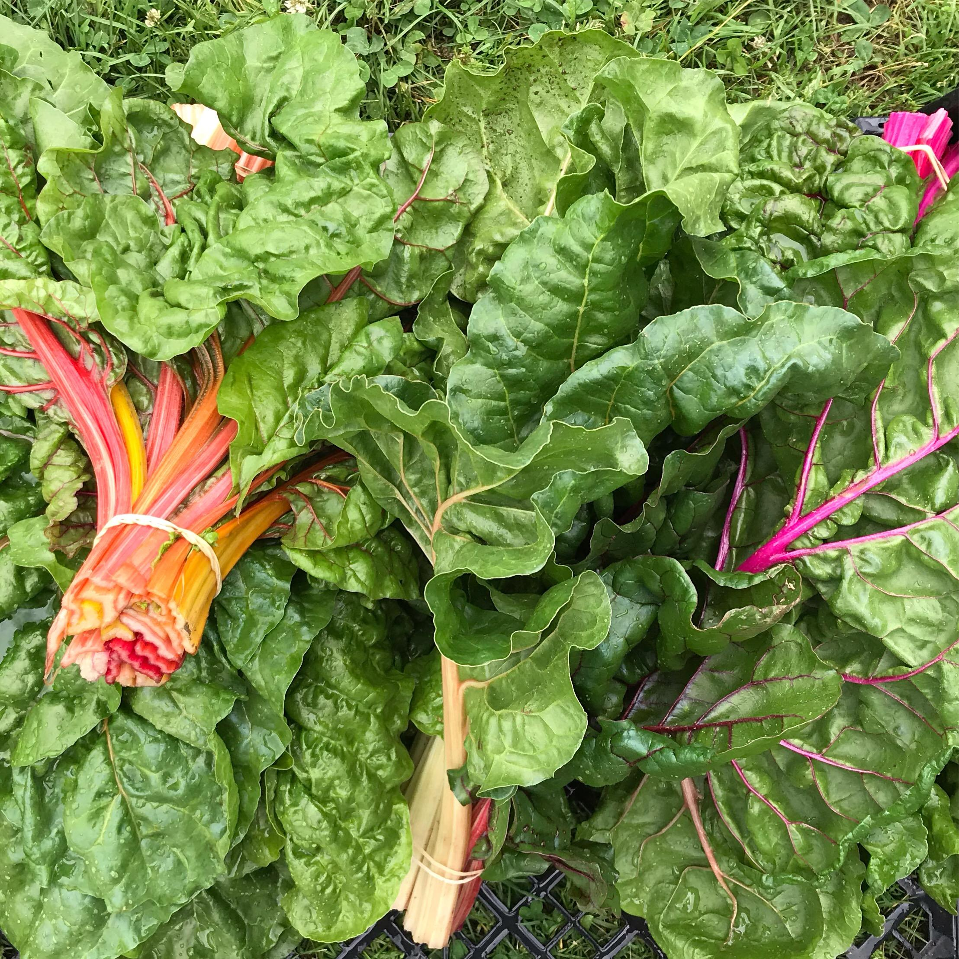
Swiss chard is a very popular leafy green in Mediterranean cuisine, thought to have originated in Sicily. Chard is actually an older, leafy variety of beets- it just doesn’t grow the big root tip, and instead, is cultivated for the tender greens. The leaves of swiss chard are shiny, green, and ribbed. The stem color varies between white, yellow, and red, depending on the cultivar. When eaten raw, chard is bitter, but cooking removes this bitterness. They can be harvested when the leaves are young and tender or when they are mature and tougher. Swiss chard can be used instead of spinach or kale in most recipes.
Selection: To select the best swiss chard look for fresh green leaves and avoid those that are yellow or discolored. Swiss chard is in season during, spring, fall, and winter.
Storage: Swiss chard is best when fresh. The best way to store it is in the refrigerator wrapped in a damp towel or placed in a plastic bag in the crisper drawer. Swiss chard will last 2-4 days like this. It can also be stored in the freezer, to do this, wash and remove any damaged pieces. Drop into boiling water for three minutes, cool the chard immediately in ice water, drain thoroughly and place in freezer bags. Remove air from the bag (to prevent freezer burn) and place it in your freezer.

Nutrients/nutrition: Swiss chard is fat-free and cholesterol-free. Swiss chard is also a good source of magnesium. In one cup of swiss chard, there is 44% of the daily value of vitamin A and 18% of the daily value of vitamin C. ² Swiss chard has been known to prevent various types of cancer, improve digestion, and boost the immune system. This versatile green is valuable to the protection and structure of bones and brain strength.¹

Preparation: Swiss chard is very versatile and can be eaten in a variety of ways. When served raw, swiss chard can be quite bitter. This flavor, however, disappears after it is cooked, resembling the consistency and soft taste of spinach (but slightly more subtle). Separate stems and ribs from the leaves either by hand or carefully with a knife. Stems and ribs can be chopped into bite-size pieces, and leaves can be stacked on top of each other and sliced crosswise into thick ribbons, roughly chopped, or torn by hand. Boil or steam swiss chard for two-three minutes. Swiss chard can also be braised, sautéed, or stir-fried.

Eat well to be well!

Seasonal Produce Guide. SNAP Education Connection. https://snaped.fns.usda.gov/seasonal-produce-guide. ² FoodData Central Search Results. FoodData Central. https://fdc.nal.usda.gov/fdc-app.html#/?query=ndbNumber:11147.

