Fermented Foods

Fermented foods have undergone a process in which we physically change the environment to promote the growth of “good” bacteria. By changing the oxygen level, acidity, and air temperature we can create this growth of good bacteria, which helps to fend off the bad bacteria, and preserve our food.

Fermenting vegetables can also be a way to make their nutrients easier to digest. For example when cabbage is fermented into sauerkraut, we absorb its vitamin C more easily. The vegetables that are fermented often change in taste and texture. The good or beneficial bacteria that have grown on the vegetables are called probiotics.

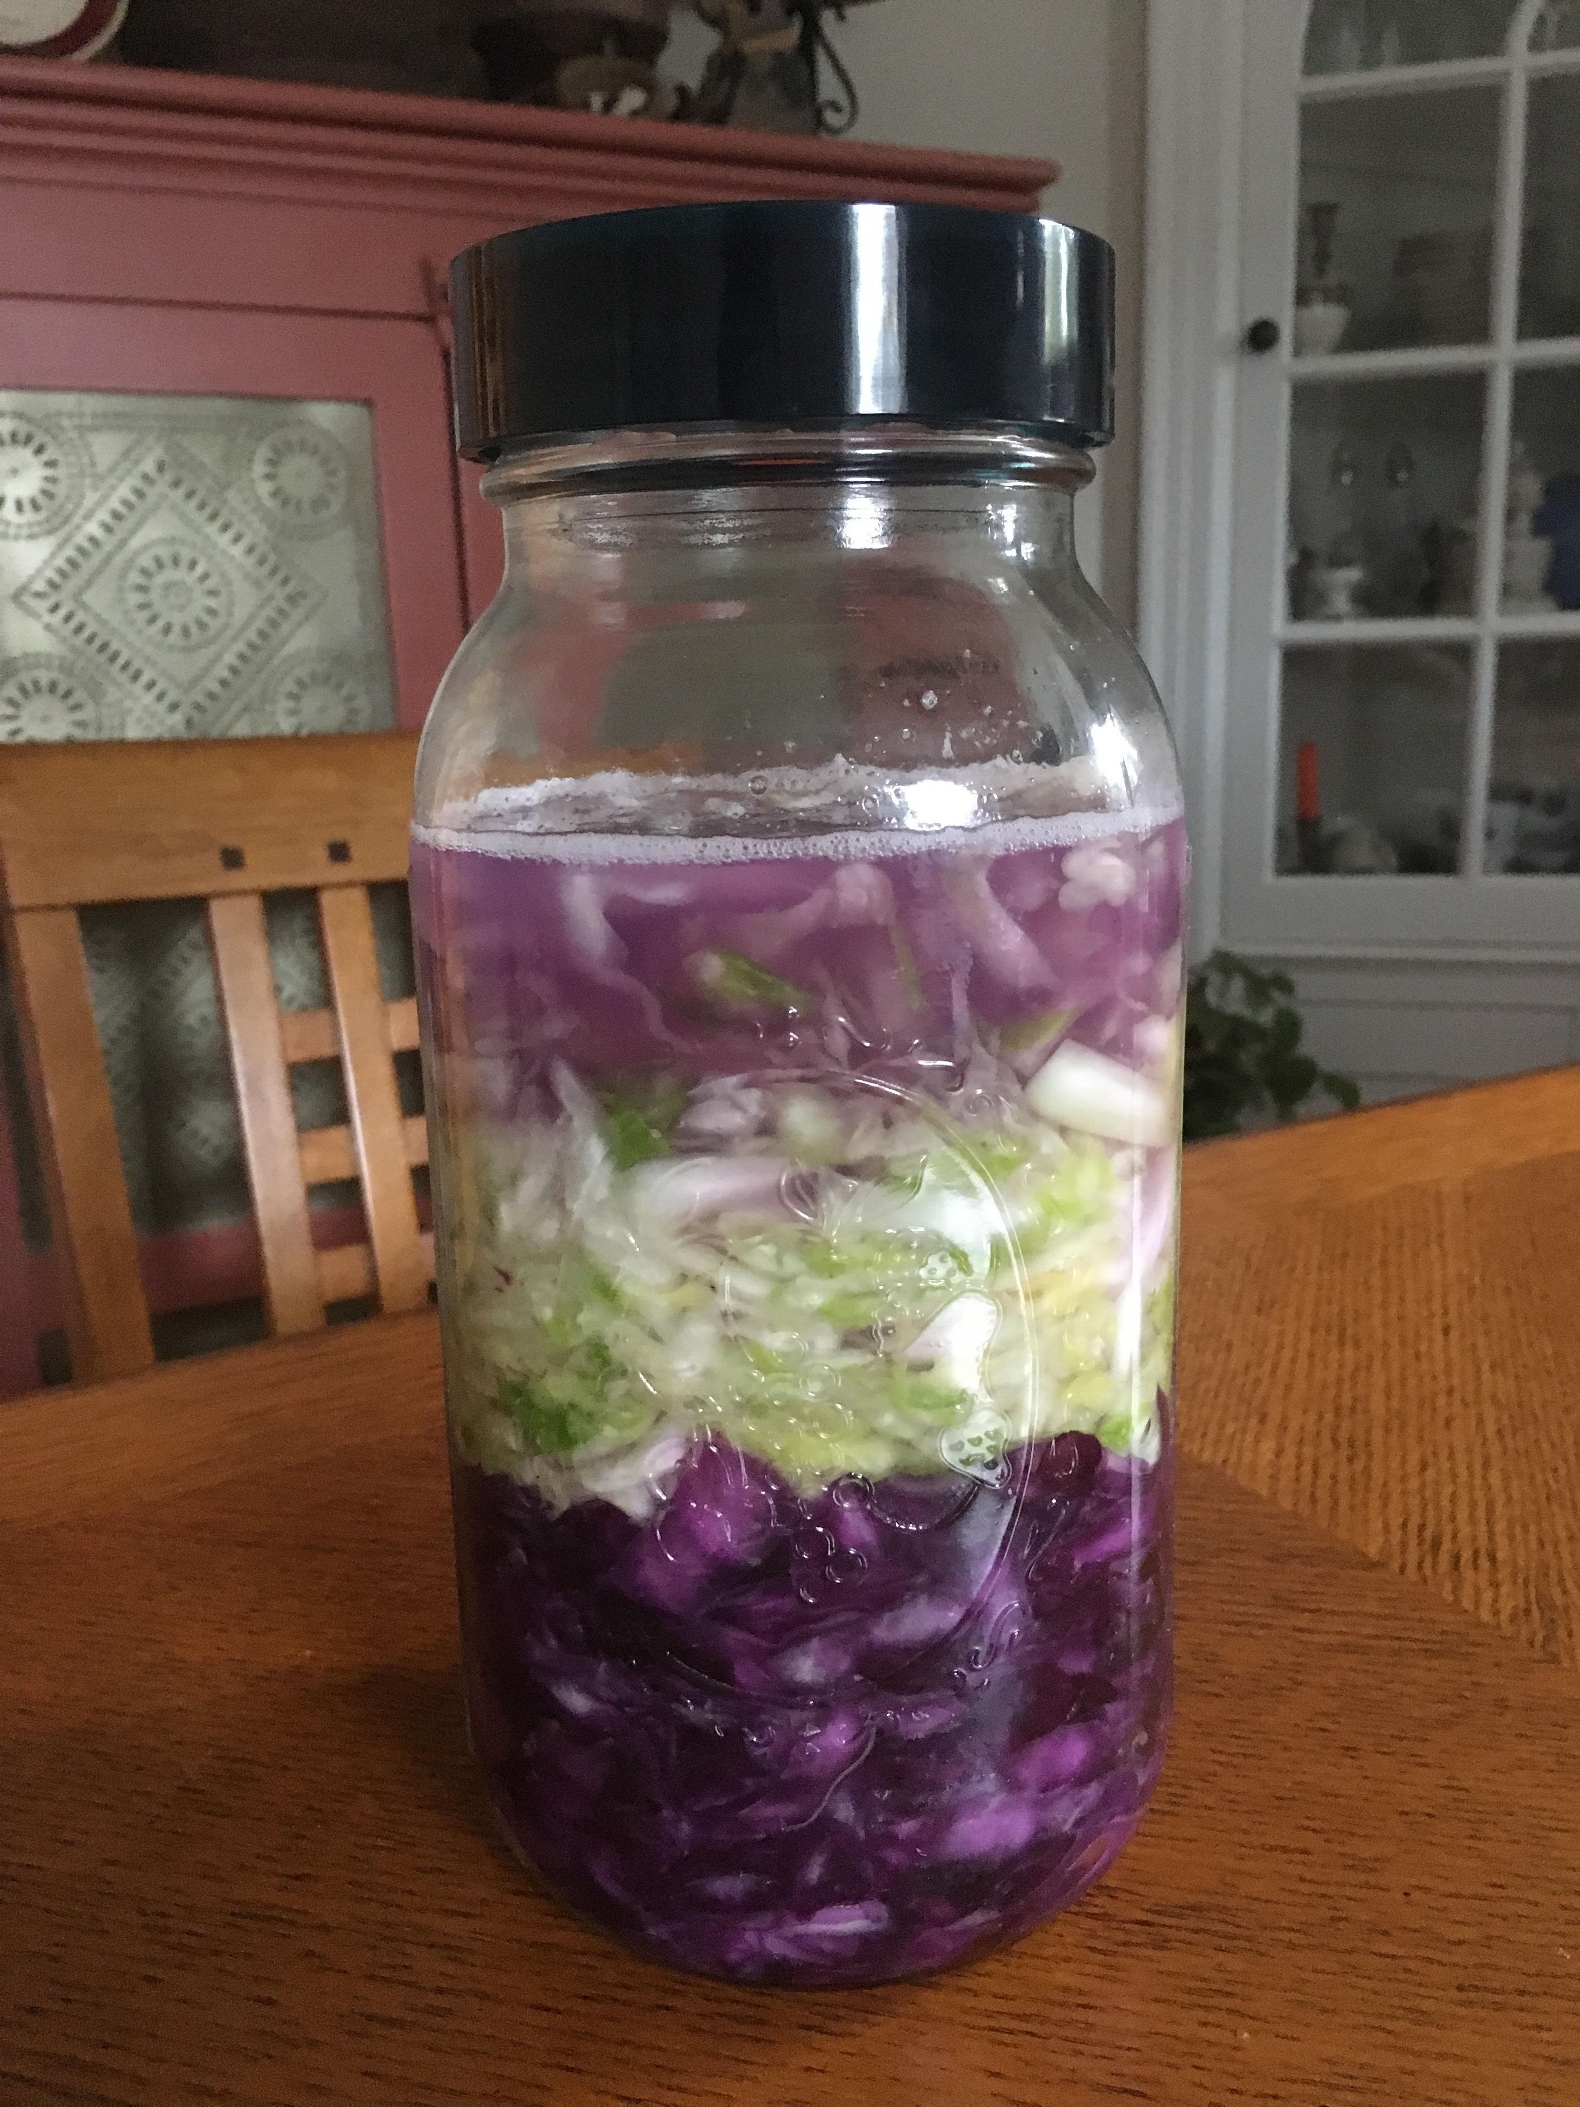
What are Probiotics?
- The live healthy bacteria that are good
for your digestive system and overall health
- Food for your microbiome (your gut!)

Why Should I Include Probiotics in My Diet?
- Boost your immune system
- Improve Digestion function
- Prevent and treat urinary tract infections
- Improve skin Conditions such as eczema
- Prevent dental cavities
- Reduce risk of chronic diseases (obesity,
heart disease, cancer)
- Treat irritable bowel syndrome

What Foods Have Probiotics in Them?
- Anything Fermented
- Sauerkraut
- Kimchi
- Kombucha
- Yogurt
- Pickles
- Tempeh

Research shows that the mircobiome has a role in the prevention and management of chronic diseases such as diabetes, cardiovascular disease, and certain type of cancers. Eating a variety of fermented foods containing probiotics may be beneficial to your overall long-term health.

