Nourse Farm CSA Food Fact Sheet

Chinese cabbage
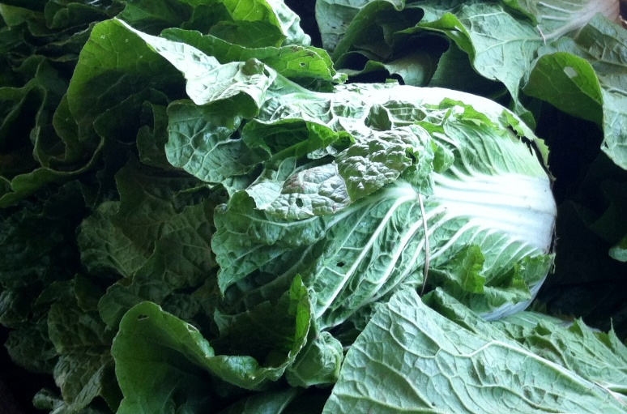

Chinese cabbage is part of the Brassica family (like Bok choy, kale, broccoli and Brussels sprouts). It has crinkly, thickly veined leaves that are tightly packed and come in quite large heads. Similar to tofu, this type of cabbage can absorb the flavors of the foods around it.

Selection: To find the best Chinese cabbage, look for firm, tightly packed heads with green - tipped leaves. Avoid cabbages with wilted leaves or small holes (these holes could indicate bugs).
Storage: To store, place the Chinese cabbage in a plastic storage bag or container. If using a bag, remove as much of the air from the bag as possible. Put the whole head in a plastic bag in the crisper of your refrigerator. Chinese cabbage will keep for about ~3 to 5 days when properly stored.
Nutrients/nutrition: Chinese cabbage is low-calorie, low-fat, and low-sodium—a one cup serving provides a body these daily values: 63% of vitamin A (eye and skin integrity), 52% of vitamin C (immune function), and as well as 7% of calcium (bone health) and 3% of iron (oxygen transport). As well, Chinese cabbage is packed with various antioxidant plant compounds (e.g., carotenes, thiocyanates, lutein, and zea-xanthin) which have been shown to offer some protection against certain types of cancers. Additionally, evidence shows that the anti-oxidants found in Chinese cabbage are also anti-inflammatory and promote overall cellular health and function.
Preparation: Chinese cabbage can be enjoyed raw or cooked...the most popular ways are in a salad or a stir fry. As mentioned above, this cabbage does take on the flavor of its accompanying seasonings and flavors so choose a favorite (garlic, ginger, etc.). To prepare, trim off the base and remove any of the outer, discolored leaves. Wash the whole cabbage in cold water. Gently pat dry or place it upside down until draining out all the water. Separate the leaves from the base pulling by hand. Once you break up its leaves and stalk, add to a variety of recipes either combined or separately (good for wraps, soups, even a plate garnish).
Eat well to be well!

All information is adapted from the United States Department of Agriculture (USDA)

